Assignment 5

Mounika Kandagadda

Question 1)

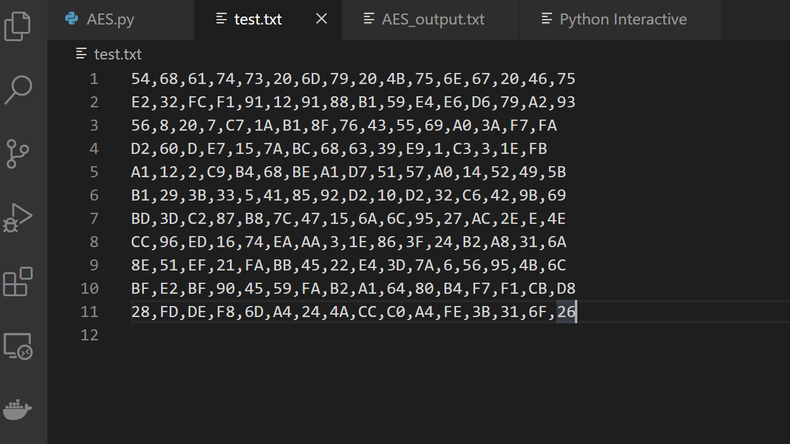

Question 2)

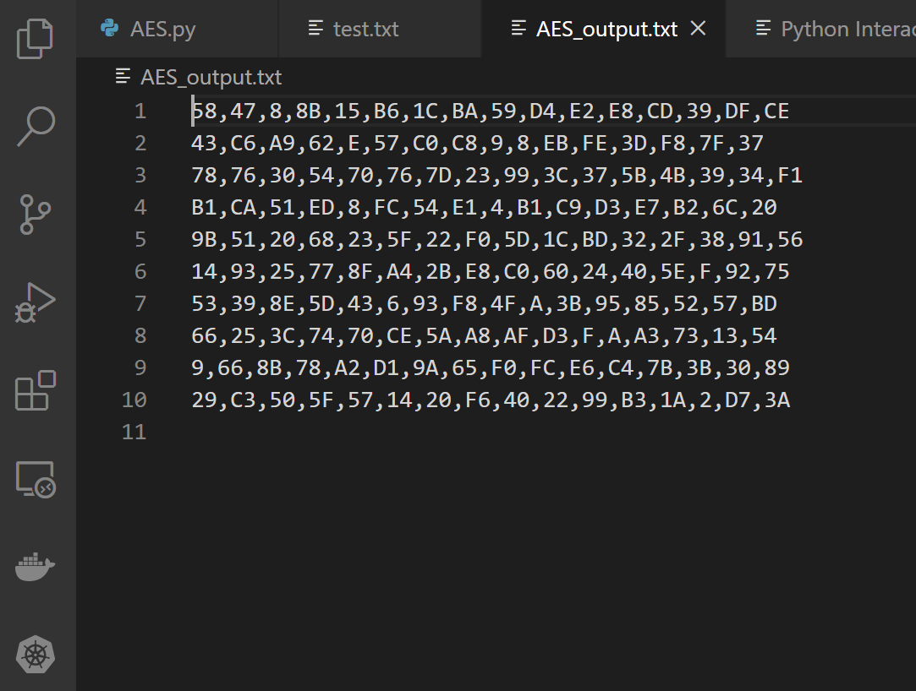

Question 3)

**Case 1) Key = “This is Too Hard”, Plaintext = “Who made this HW”**

Cipher Text: 7B,D3,56,2E,38,D6,93,BD,98,25,A2,88,3C,0,62,E7

**Case 2) Key = “Wooww I Finished”, Plaintext = “This took Forevr”**

Cipher Text: CA,12,EA,B6,1D,24,B8,5,5D,6,D3,CF,8E,D3,15,61